**Pairing your new Thermacycle remote with your Thermacycle Base Unit:**

1. **When the machine powers on, please press and hold this button 1688609078363 for 5-7 seconds until numbers are shown on the touchscreen.**

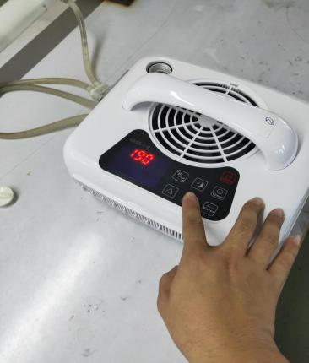

1. **Press these two buttons at the same time for 5 seconds.**

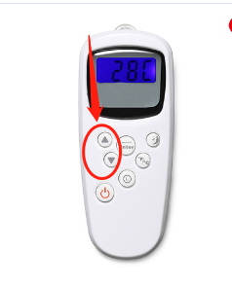

1. **Try to use the remote as normal. If the machine responds, pairing is complete.**